Chemical Monthly Report (CMR)
4th July 2024

Contact:
Dr Moncef HADHRI, Economic Affairs, mha@cefic.be
Media contact: Ellen MULDER, emu@cefic.be

EU chemical industry is making slow strides forward

- Summary

- The overall chemicals business climate appears to be more stable: Managers’ opinion on order books is slightly up, but still reflects limited demand, and while uncertainty about their future business situation decreased in retail trade and services, it remained stable in industry and construction.

- It also seems the EU27 chemical industry has moved beyond its ultimate low in terms of output and capacity utilisation, and is finally showing a positive trend: Output in Q1-2024 was 1.8% higher than in Q4-2023, and there was a small increase of capacity utilisation in the EU27 chemical industry from 74.4% in Q3-2023 to 75.5% in Q1-2024, staying well below the long-term average of 81.4%.

- In Q1 2024, the EU27 chemicals trade surplus reached the highest value since Q1 2022 (€14.8 bn). The EU27 chemicals exports to non-EU27 area increased by €5.6 bn from Q4-2023 to Q1-2024. The country analysis shows that USA and UK contributed largely to this positive development.

- That said, these encouraging numbers should be taken with a grain of salt, given that their benchmark is 2023: a year where production was still far below pre-covid levels. A strong recovery in 2024 is unlikely when most of the chemical industry’s downstream users – rubber & plastics, textiles, construction, computer production – are still showing downward trends.

- Industrial production in many developed economies expected to grow
Latest data from the Oxford Economics Monthly Report shows that the global manufacturing Purchasing Managers' Index (PMI) continues to be positive at 50.3 (chart on the left, vertical axis on right side). The further away from 50, the greater the level of change: A PMI above 50 represents an expansion when compared to the previous month, a PMI value under 50 represents a decline, while a reading at 50 indicates no change.

Yet in which phase of growth are the main economies? To this end, Oxford Economics built a new proprietary industrial Business Cycle Tracker (BCT) (chart on the right).
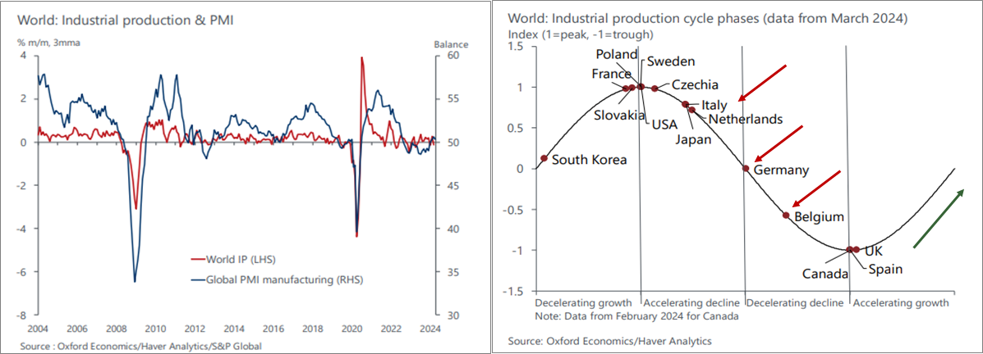
Source: Oxford Economics Monthly Industry Briefing (May 2023)

The tracker shows starkly how the majority of Europe is lagging behind globally: Germany, Italy, and Belgium, among others, are still caught in the decline phases of the industrial business cycle while others, most prominently the UK, South Korea, and the US are set to experience an upturn. The BCT suggests that industrial production in many developed economies has reached its lowest point and is now poised to enter a period of growth, with nations such as France and Sweden leading the pack (source: Oxford Economics Monthly Industry Briefing/Global Industry-May 2024).

- The current level of overall order books shows a slight improvement
The managers’ opinion on the current level of overall order books shows a slight improvement in June 2024 compared to May 2024, but still reflects the lack of demand for the chemical industry. As expected, the ongoing destocking trend is coming to the end. We see in June 2024 the third upturn in the stock level after six months of decline. Data on managers’ production expectations continued to show a decline, but is still in positive digits. According to the latest EU27 business and consumer survey, the uncertainty indicator declined for the fifth month in a row. Consumers’ uncertainty about their future financial situation dropped. Managers’ uncertainty about their future business situation decreased in retail trade and services, while it remained stable in industry and construction. To sum up, the EU27 chemicals business environment shows slight improvement on the demand side. We are still waiting for a solid sign of sustained recovery.

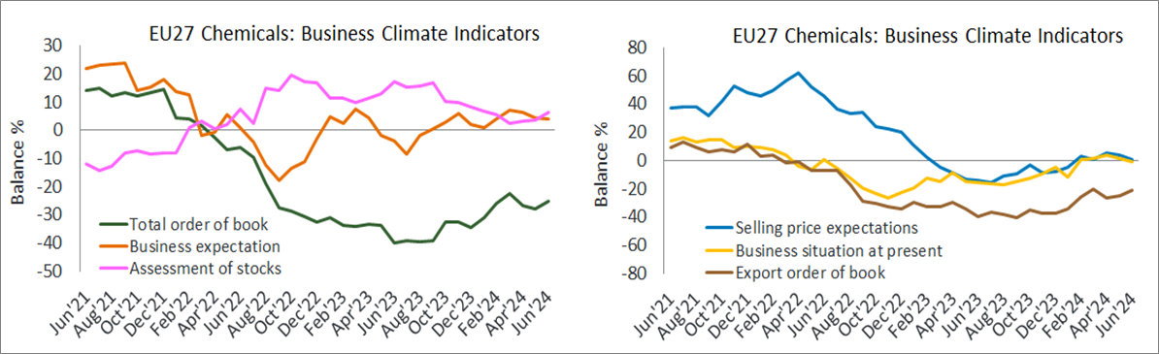
Source: EU27 commission business and consumer survey and Cefic analysis (2024)

- EU27 chemicals production on the road to recovery in 2024
Output of the EU27 chemical sector increased for the third consecutive quarter since Q3-2023. Production in Q3-2023 was 1.2% above Q2-2023 levels. The end of 2023 was relatively flat compared to Q3-2023. Output in Q1-2024 was 1.8% higher than in Q4-2023, and 2.4% above Q1-2023 levels. The EU27 chemical industry seems to have reached its ultimate low. However, given the lack in demand growth, the European chemical industry production volumes are still not completely recovering.

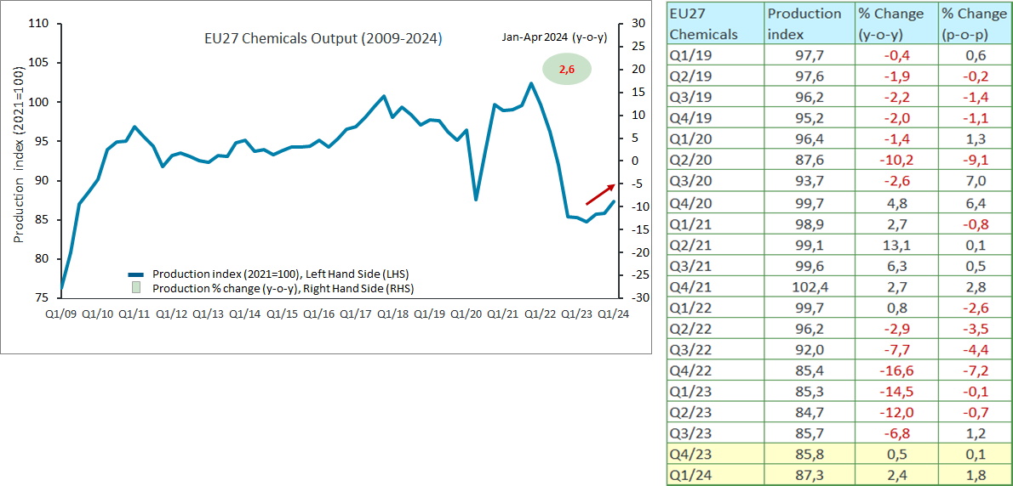
Source: Eurostat and Cefic analysis (2024)

- EU27 chemicals capacity utilisation improves after the Q1-2023 ‘low’
In line with the production trend, capacity utilisation has shown encouraging signs during the past two quarters. The chart below reports an increase of capacity in the EU27 chemical industry from 74.4% in Q3-2023 to 75.5% in Q1-2024. However, the current level of capacity is still far below the long-term average of 81.4%.

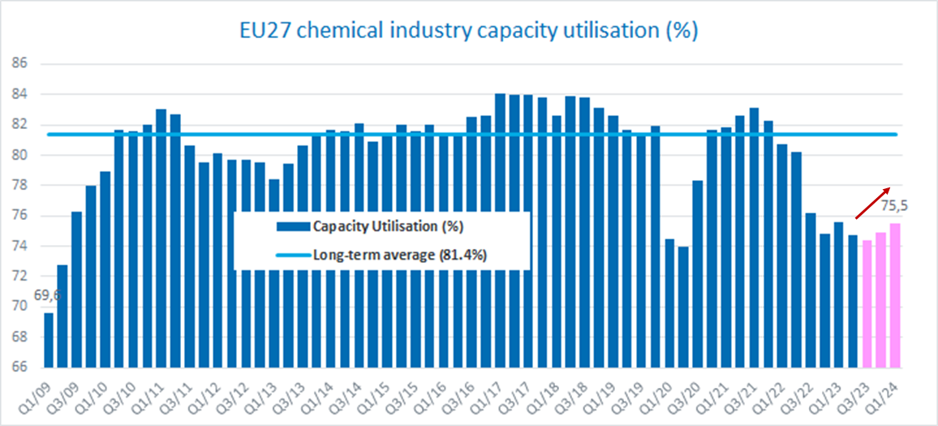
Source: Eurostat and Cefic analysis (2024)

- EU27 chemical industry output outperforms other EU27 manufacturing sectors (Jan-Apr)
At -3.6%, output of the entire EU27 manufacturing sector was significantly lower during the first four months of 2024 compared to the same period in 2023. The largest output decline is attributable to the pharmaceuticals sector: production declined by more than 10% in 2024 compared to 2023 (Jan-April). Rubber and plastics only saw a 2% decline compared to Jan-Apr 2023. Only three sectors appear to achieve better results: food and beverage, paper, and chemicals. At +2.6%, the EU27 chemical industry reported the highest output increase among the EU27 manufacturing sectors, equivalent to paper (around 2.6%) and followed by food and beverage (2.5%). Despite this upward trend, we need to keep in mind that the benchmark for these numbers is 2023: a year where production was far below pre-covid levels.

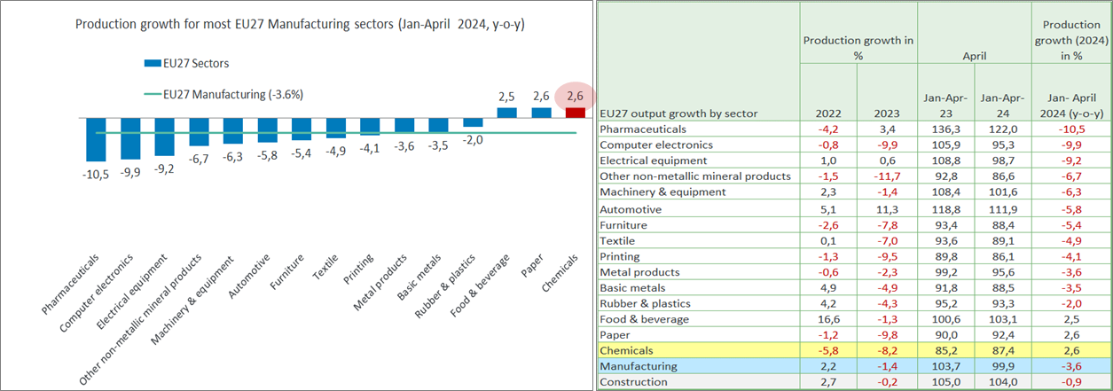
Source: Eurostat and Cefic analysis (2024)

- Main EU27 countries showed better production results in 2024 (Jan-Apr)
Nearly half of EU27 chemicals sales was attributed to the two main locomotives (47.9%, data 2022). Data analysis shows a patchy situation across EU27 Member States: chemicals production grew in Germany (2.9%), and France (3.1%) in 2024, compared to 2023 (Jan-April). The growth in the Netherlands (3.8%) and Spain (6.8%) is even higher. However, the chemical industry in Italy reported a drop in production of 1.4%. Apart from Italy and a few other Member States, the chemical industry in the largest EU economies started the new year better than expected. The significant increase in chemical volumes throughout the first four months of 2024 (+2.6%, y-o-y) could still be linked to a short-term restocking rather than a stabilised demand and ongoing recovery. A lack of orders and cost problems continue to impact the mood among European chemicals companies.

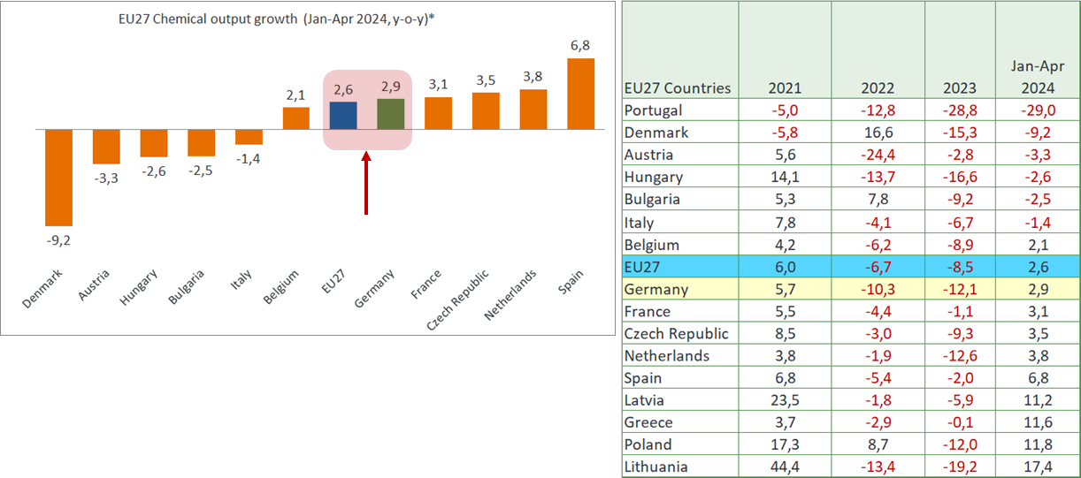
Source: Eurostat and Cefic analysis (2024)

- EU27 chemicals trade surplus reached the highest level (€14.8 bn) since Q1-2002
The recovery of the chemicals trade flows has been awaited for a very long time. We did not see a positive trend in neither exports nor imports since Q3-2022. Fortunately, chemical trade activity started the new year better than expected. EU27 chemical exports reached the value of €57.3 bn in Q1-2024, up from €51.7 bn in Q4-2023. Further, imports went slightly down from €43.6 bn in Q4-2023 to €42.5 bn in Q1-2024. As a result, the EU27 chemicals trade surplus reached in Q1-2024, the highest level since Q1-2002 (€14.8 bn).

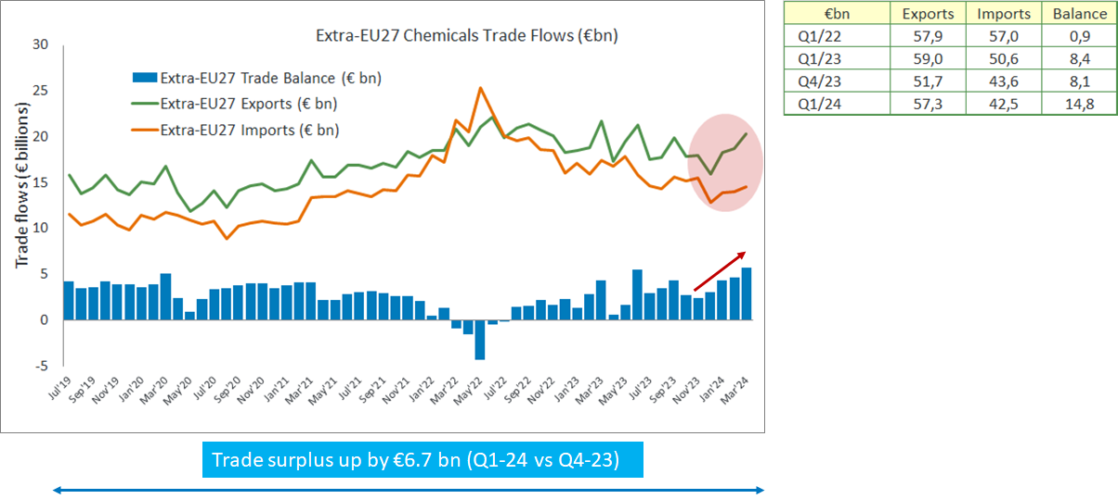
Source: Eurostat and Cefic analysis (2024)

- Specialty chemicals contribute most to EU27 chemical exports in 2024
The EU27 chemical industry covers three main product areas: base chemicals, specialty chemicals and consumer chemicals. Specialty chemicals cover areas such as paints and inks, crop protection, dyes and pigments, and auxiliaries for industry (other chemicals such as glues, essential oils and gelatine). Specialty chemicals are produced in small volumes, but they nevertheless represented more than 25% of total EU27 chemical sales. Consumer chemicals are sold to final consumers, such as soaps and detergents as well as perfumes and cosmetics.

Trade data shows that EU27 chemicals exports reached €57.3 billion in Q1-2024. Specialty chemicals (€19 bn) is the largest exporting sector, accounting for 33% of total EU27 chemical exports in value, followed by petrochemicals, contributing 22% of the total. With €10.3 bn, consumer chemicals came third (18%). 2024 shows a strong start reaching an increase of €5.7 bn in Q1-2024 compared to Q4-2023. More than half of these exports surplus (€5.6 bn) is attributable to both petrochemicals (€1.7 bn) and specialty chemicals (€1.5 bn).

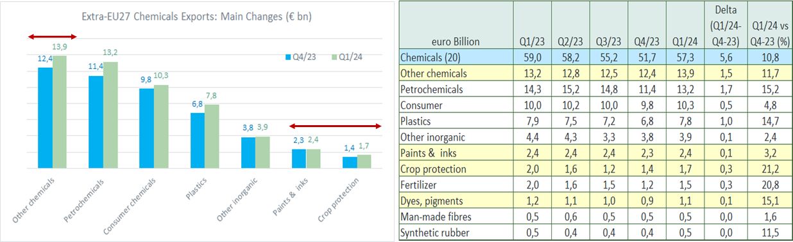
Source: Eurostat and Cefic analysis (2024)

EU27 chemicals exports to non-EU27 area increased by €5.6 bn from Q4-2023 to Q1-2024. The country analysis shows that USA and UK contributed largely to this positive development. EU27 exports to the USA increased significantly from €8.3 bn in Q4-2023 to €9.9 bn in Q1-2024. EU27 exports to UK increased from €5.9 bn to €7.2 bn during the same period. The USA and UK markets are the two main sources of the EU27 chemical export surplus in Q1-2024.

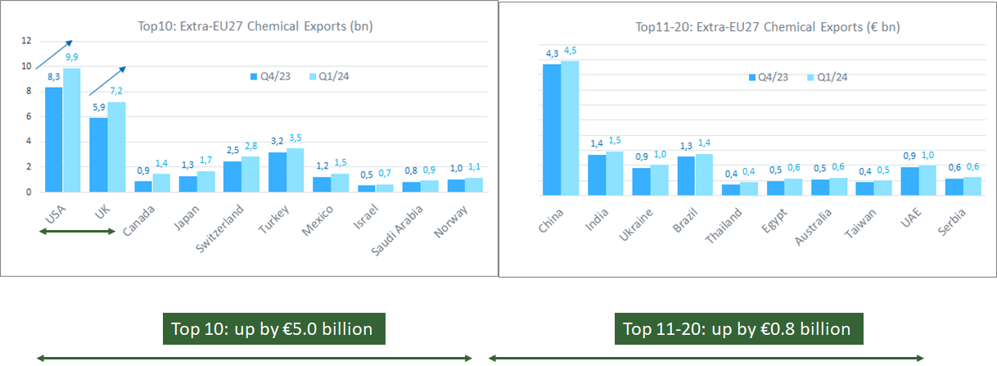
Source: Eurostat and Cefic analysis (2024)

- Global chemicals production, up by 4.4% in 2024 (Jan-Apr)
China continues to lead the global chemicals production in 2024, and accounts for more than 40% of global chemicals sales. The latest monthly data shows a high level of production in China in December 2023, followed by a clear negative trend from December 2023 (index, 123.7) to April 2024 (index, 115.0). While the UK is still not showing signs of recovery in 2024, the EU27 area reported better results (+2.6%). The USA shows no significant growth. Overall, global chemical output grew by more than 4% during the first four months of 2024 compared to 2023. The global demand is still weak and the high energy costs will continue to weigh on the sectors prospects into 2024-2025.

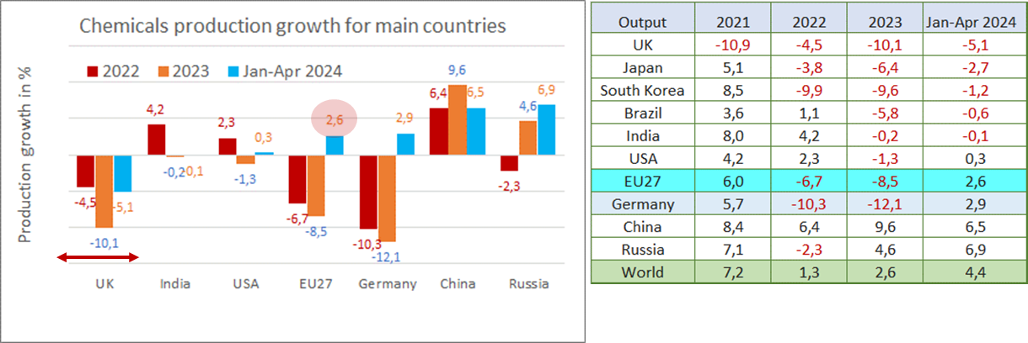
Source: Eurostat and Cefic analysis (2024)

Unless specified, chemical industry excludes pharmaceuticals.

